Website About Page

“All the ends of the earth shall remember

and turn to the Lord,

and all the families of the nations

shall worship before you.”

Psalm 22:27

Japan is one of the most unreached people groups in the entire world. Less than 0.5% of the population is Christian. In a nation of 125 million people, roughly 95% have never heard the Gospel. This, then, is surely a field ripe for the harvest (Matthew 9:38).

This is Nagoya

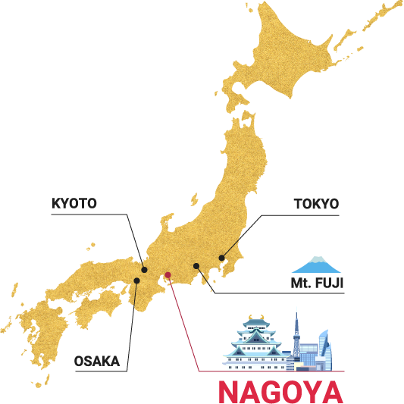

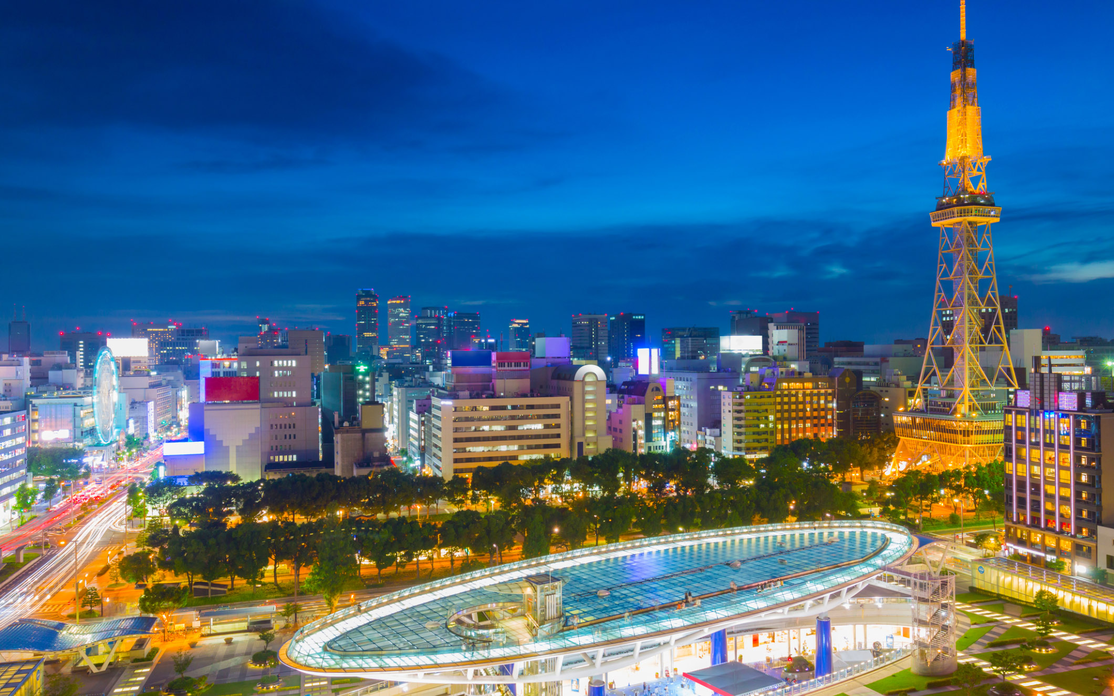

Located in the Aichi prefecture (or region), often referred to as the heart of Japan, Nagoya is Japan’s fourth largest city with a population of 2.3 million. Nagoya is known as the center of both samurai culture and the automotive industry. The Aichi prefecture has more Buddhist and Shinto temples than any other area in Japan, and just one church for every 28,500 people.

Mission to the World has planted five churches in Nagoya and started several ministries that engage and serve the people of the city. Many of our missionaries dedicate their entire lives to loving the people and preaching the Gospel in word and deed.

In 2020, Mission to the World’s Nagoya church planting team launched a school with the goal of supporting missionary and other Christian families in the area. Nagoya Christian School, or NCS, provides a place for missionary children to learn in their native language, while learning skills (such as Japanese) to engage with the culture they live in, and a home for Christian fellowship and growth. The staff is made up of trained missionaries, Japanese teachers, and volunteers.

That’s where I come in - and it’s where you can come in, too!

Hello! I’m Margaret Rodgers, an intern with Mission to the World. I’m raising support for an eleven-month internship in Nagoya, Japan, where I will work as a teaching assistant in Nagoya Christian School from August 2026 - July 2027. I believe God is calling me to serve the missionaries in Nagoya by helping to teach their children, and to help share the Gospel with the Japanese people who need Him so desperately. I would love for you to be part of this mission, by praying for me and the mission and also, perhaps, through financial support. Either way, I’m so glad you’re here, and I’m so very excited for the opportunity to be a part of God’s work in Japan.

**“** For I am not ashamed of the gospel, for it is the power of God for salvation to everyone who believes.” Romans 1:16